**Product datasheet**

**Rabbit Anti MMAE Antibody, mAb**

Cat: NA0147

Name:Rabbit Anti MMAE Antibody, mAb

Immunogen: MMAE conjugated to keyhole limpet haemocyanin(KLH)

Host Species: Rabbit

Specificity:This antibody recognizes MMAE and MMAE structurally similar molecules.

Form: Liquid

Concentration: 0.5 mg/ml

Storage Buffer: 1×PBS, pH7.4, containing 0.1% BSA, 50% glycerol and 0.03% Proclin 300.

Purification: Purified by Protein A

Clonality: Monoclonal

Clone ID: 7E7

Shipping and Storage: Shipped in ice bag. The antibody can be stored for 1-2 weeks at 2-8°C. For long term storage, store it at -20°C. Avoid repeated freezing and thawing cycles.

Expiration Date: Specified on product label.

Applications

|  |  |
| --- | --- |
| **Application** | **Recommended Usage** |
| ELISA | 0.1-2 µg/ml |
| Other applications | User-optimized |

Note: Ningyang Biotech can offer this product according to your requirement, including product size, buffer components, etc.

Examples

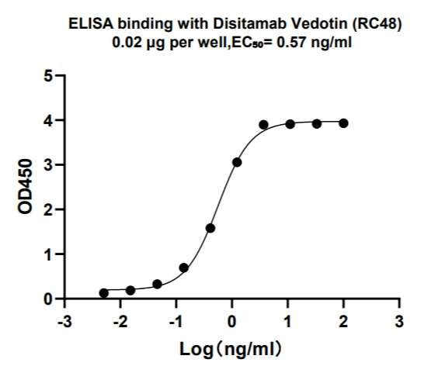

Rabbit Anti MMAE Antibody, mAb (Cat:NA0147) binds with Disitamab Vedotin (RC48).   
Coating antigen: Disitamab Vedotin (RC48) ,0.2 μg/ml, 100 μL/well.

Rabbit Anti MMAE Antibody, mAb (Cat:NA0147) dilution start from 100 ng/ml.  
EC₅₀= 0.57 ng/ml.

**For research use only.** **Not intended for human and animal therapeutic or diagnostic use.**