**Product datasheet**

**Rabbit Anti Avi Tag Antibody, pAb**

Cat: NA0050

Name:Rabbit Anti Avi Tag Antibody, pAb

Immunogen: Avi tag peptide conjugated to keyhole limpet haemocyanin(KLH)

Host Species: Rabbit

Specificity:This antibody recognizes C-terminal and N-terminal Avi tag fusion proteins.

Form: Liquid

Concentration: 0.5 mg/ml

Storage Buffer: 1×PBS, pH7.4, containing 50% glycerol and 0.03% Proclin 300.

Purification: Antigen affinity purification

Clonality: Polyclonal

Isotype: Rabbit IgG

Shipping and Storage: Shipped in ice bag. The antibody can be stored for 1-2 weeks at 2-8°C. For long term storage, store it at -20°C. Avoid repeated freezing and thawing cycles.

Expiration Date: Specified on product label.

Applications

|  |  |
| --- | --- |
| **Application** | **Recommended Usage** |
| ELISA | 0.05-0.5µg/ml |
| Western Blot | 0.1-1µg/ml |
| Other applications | User-optimized |

Note: Ningyang Biotech can offer this product according to your requirement, including product size, buffer components, etc.

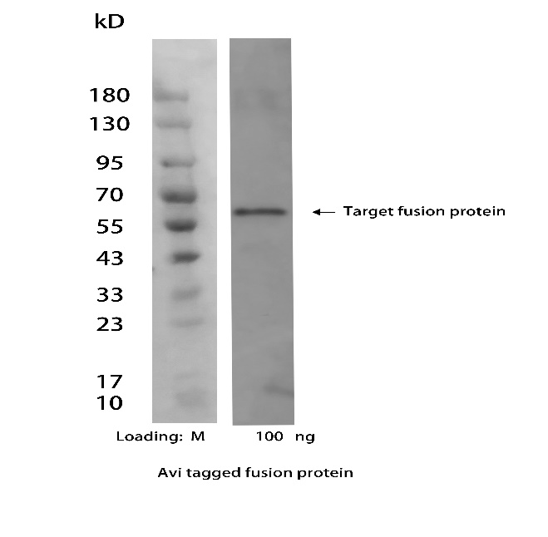

**Figure 1**. Detection of Avi tag in recombinant fusion protein were analyzed by Western blot using Rabbit Anti Avi Tag Antibody, pAb (NingyangBiotech,Cat.NA0050, at 1 µg/mL concentration).

The signal was developed with Goat Anti-Rabbit IgG(H&L)[HRP], pAb(NingyangBiotech Cat.NA0030).

**For research use only.** **Not intended for human and animal therapeutic or diagnostic use.**