**Product datasheet**

**Mouse Anti Strep II Tag Antibody, mAb**

Cat: NA0084

Name:Mouse Anti Strep II Tag Antibody, mAb

Immunogen: KLH conjugated Strep II tag(WSHPQFEK) peptide

Host Species: Mouse

Specificity:This antibody recognizes Strep II tags localized at the N-terminal and C-terminal region of Strep II-tagged fusion proteins.

Form: Liquid

Concentration: 0.5 mg/ml

Storage Buffer: 1×PBS, pH7.4, containing 0.1% BSA, 50% glycerol and 0.03% Proclin 300.

Purification: Purified by Protein A

Clonality: Monoclonal

Isotype: Mouse IgG1, κ

Clone ID: 3D10

Shipping and Storage: Shipped in ice bag. The antibody can be stored for 1-2 weeks at 2-8°C. For long term storage, store it at -20°C. Avoid repeated freezing and thawing cycles.

Expiration Date: Specified on product label.

Applications

|  |  |
| --- | --- |
| **Application** | **Recommended Usage** |
| ELISA | 0.05-0.2 µg/ml |
| Western Blot | 0.1-1µg/ml |
| Other applications | User-optimized |

Note: Ningyang Biotech can offer this product according to your requirement, including product size, buffer components, etc.

Examples

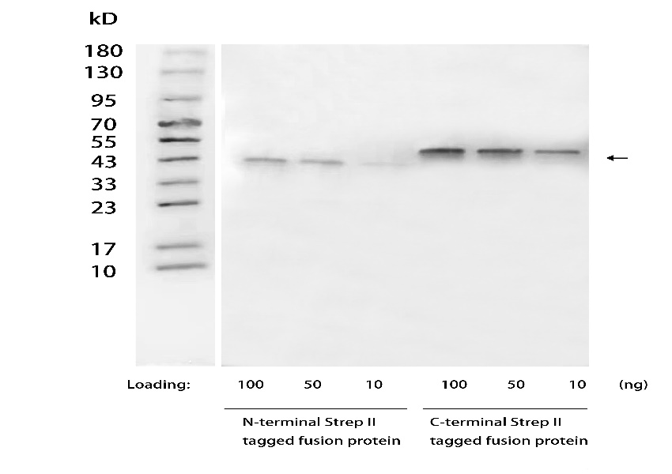

**Figure 1**. Detection of C- or N-terminal Strep II tags in recombinant fusion proteins were analyzed by Western blot using Mouse Anti Strep II Tag Antibody, mAb (NingyangBiotech,Cat.NA0084, at 1 µg/mL concentration).

The signal was developed with Goat Anti-Mouse IgG(H&L)[HRP], pAb(NingyangBiotech Cat.NA0035).

The results show that Mouse Anti Strep II Tag Antibody, mAb (NingyangBiotech, NA0084) can recognize C-terminal and N-terminal Strep II tagged proteins.

**For research use only.** **Not intended for human and animal therapeutic or diagnostic use.**