**Product datasheet**

**Mouse Anti-Rabbit IgG Antibody[HRP], mAb**

Cat: NA0090

Name:Mouse Anti-Rabbit IgG Antibody[HRP], mAb

Immunogen: Rabbit IgG (H&L)

Host Species: Mouse

Specificity:The antibody reacts with the rabbit IgG and has no cross-reactivity with human, goat, chicken, guinea pig, mouse, rat and monkey immunoglobulins. This antibody only reacts with native rabbit IgG and does not bind to the denatured or reduced rabbit IgG heavy chain or light chain.

Form: Liquid

Concentration: 1 mg/ml

Storage Buffer: 1×PBS, pH7.4, containing 1% BSA, 0.03% Proclin 300 and 50% glycerol.

Conjugate: Horseradish peroxidase (HRP)

Clonality: Monoclonal

Isotype: Mouse IgG2a, κ

Clone ID: 4H9

Shipping and Storage: Shipped in ice bag. For long term storage, store it at -20°C. Avoid repeated freezing and thawing cycles.

Expiration Date: Specified on product label.

Applications

|  |  |
| --- | --- |
| **Application** | **Recommended Usage** |
| ELISA | 1:20,000-1:50,000 |
| Western Blot | 1:20,000-1:40,000 |
| Other applications | User-optimized |

Note: Ningyang Biotech can offer this product according to your requirement, including product size, buffer components, etc.

Examples

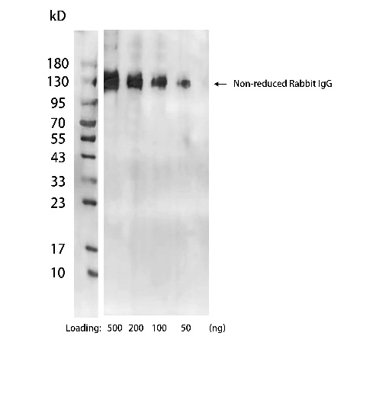

**Figure 1**. Rabbit IgG was detected by Western blot using Mouse Anti-Rabbit IgG Antibody[HRP], mAb (NingyangBiotech, Cat.NA0090).

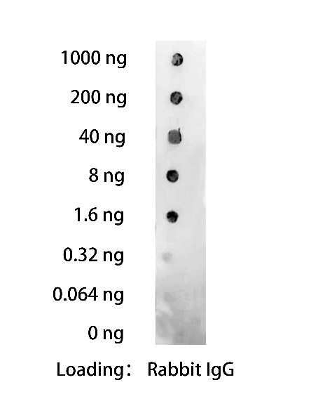

**Figure 2**. Rabbit IgG was detected by Dot blot using Mouse Anti-Rabbit IgG Antibody[HRP], mAb (NingyangBiotech, Cat.NA0090).

**Figure 3**. Variety of immunoglobulin G were tested in ELISA with Mouse Anti-Rabbit IgG Antibody[HRP], mAb (NingyangBiotech, Cat.NA0090). It had no cross-reactivity with human IgG, goat IgG, chicken IgY, guinea pig IgG, mouse IgG, rat IgG and monkey IgG.

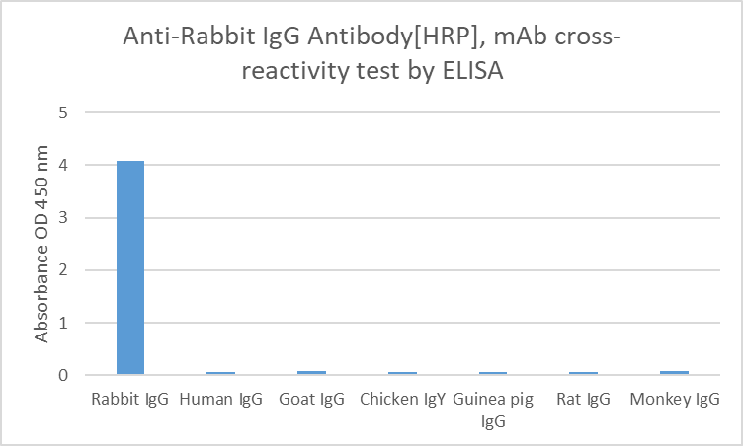

**For research use only.** **Not intended for human and animal therapeutic or diagnostic use.**