**Product datasheet**

**Mouse Anti PEG Antibody[HRP], mAb**

Cat: NA0088

Name:Mouse Anti PEG Antibody[HRP], mAb

Immunogen: Polyethylene glycol conjugated to keyhole limpet haemocyanin(KLH)

Host Species: Mouse

Specificity:This antibody recognizes PEG40K,PEG20K,PEG5K,PEG12,PEG4,PEG2 and PEG conjugates.

Form: Liquid

Concentration: 0.5 mg/ml

Storage Buffer: 1×PBS, pH7.4, containing 1% BSA,50% glycerol and 0.03% Proclin 300.

Conjugate: Horseradish peroxidase (HRP)

Clonality: Monoclonal

Isotype: Mouse IgG2b,κ

Clone ID: 6B12E10

Shipping and Storage: Shipped in ice bag. The antibody can be stored for 1-2 weeks at 2-8°C. For long term storage, store it at -20°C. Avoid repeated freezing and thawing cycles.

Expiration Date: Specified on product label.

**Note:** Some reagents with structures similar to PEG, such as Tween-20, Triton X-100, and NP-40 can affect the detection of PEG antibody. The detection system cannot contain such reagents.

Applications

|  |  |
| --- | --- |
| **Application** | **Recommended Usage** |
| ELISA | 0.1-1 µg/ml |
| Western Blot | 0.1-1µg/ml |
| Other applications | User-optimized |

Note: Ningyang Biotech can offer this product according to your requirement, including product size, buffer components, etc.

Examples

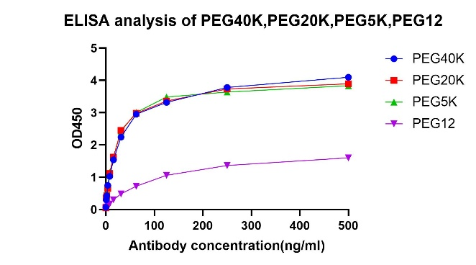ELISA analysis of PEG40K, PEG20K, PEG5K and PEG12 using Mouse Anti PEG Antibody[HRP],mAb (Cat.No. NA0088).

Detection of variety of PEG2-peptide, PEG4-peptide using Mouse Anti PEG Antibody[HRP],mAb (Cat.No. NA0088, 0.5 µg/ml). 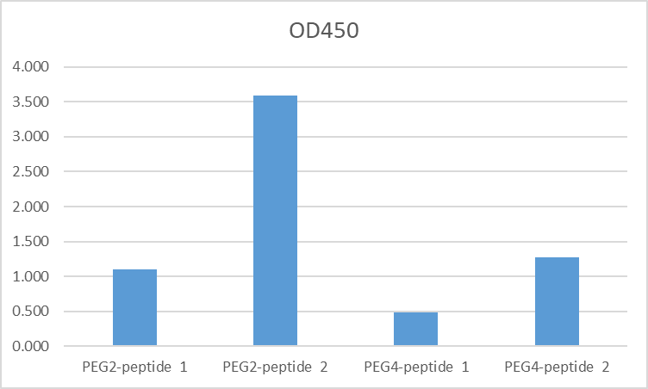

**For research use only.** **Not intended for human and animal therapeutic or diagnostic use.**