**Product datasheet**

**Mouse Anti KLH Antibody, mAb**

Cat: NA0175

Name:Mouse Anti KLH Antibody, mAb

Immunogen: Keyhole limpet haemocyanin(KLH)

Host Species: Mouse

Specificity:This antibody recognizes KLH and no cross-reactivity with BSA and OVA.

Form: Liquid

Concentration: 0.5 mg/ml

Storage Buffer: 1×PBS, pH7.4, containing 0.1% BSA, 50% glycerol and 0.03% Proclin 300.

Purification: Purified by Protein A

Clonality: Monoclonal

Isotype: Mouse IgG1,κ

Clone ID: 18D12

Shipping and Storage: Shipped in ice bag. The antibody can be stored for 1-2 weeks at 2-8°C. For long term storage, store it at -20°C. Avoid repeated freezing and thawing cycles.

Expiration Date: Specified on product label.

Applications

|  |  |
| --- | --- |
| **Application** | **Recommended Usage** |
| ELISA | 0.1-1 µg/ml |
| Western Blot | 0.1-1µg/ml |
| Other applications | User-optimized |

Note: Ningyang Biotech can offer this product according to your requirement, including product size, buffer components, etc.

Examples

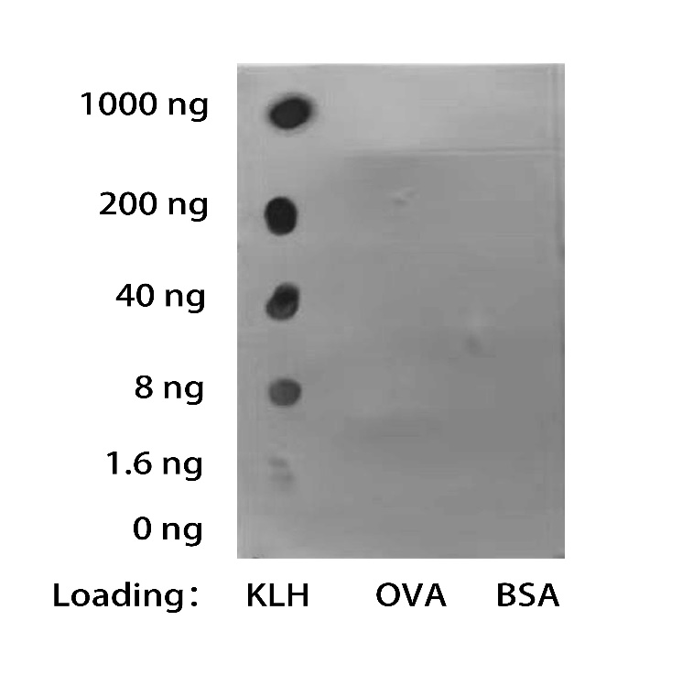

The test results show that the KLH Antibody could detect KLH and no cross-reactivity with BSA and OVA. The signal was developed with Goat Anti-Mouse IgG(H&L)[HRP], pAb(NingyangBiotech Cat.NA0035).

**For research use only.** **Not intended for human and animal therapeutic or diagnostic use.**