**Product datasheet**

**Mouse Anti-Human IgG Fc Antibody****(15B2), mAb**

Cat: NA0164

Name: Mouse Anti-Human IgG Fc Antibody(15B2), mAb

Immunogen: Human IgG Fc

Host Species: Mouse

Specificity:This antibody reacts with the Fc portion of human IgG and has no cross-reactivity with rabbit, goat, chicken, dog, pig, sheep and alpaca immunoglobulins.

Form: Liquid

Concentration: 1 mg/ml

Storage Buffer: 1×PBS, pH7.4, containing 0.1% BSA, 50% glycerol and 0.03% Proclin 300.

Purification: Purified by Protein A

Clonality: Monoclonal

Isotype: Mouse IgG1, κ

Clone ID: 15B2

Shipping and Storage: Shipped in ice bag. The antibody can be stored for 1-2 weeks at 2-8°C. For long term storage, store it at -20°C. Avoid repeated freezing and thawing cycles.

Expiration Date: Specified on product label.

Applications

|  |  |
| --- | --- |
| **Application** | **Recommended Usage** |
| ELISA | 1:5,000-1:20,000 |
| WB | 1:5,000-1:20,000 |
| Other applications | User-optimized |

Note: Ningyang Biotech can offer this product according to your requirement, including product size, buffer components, etc.

Examples

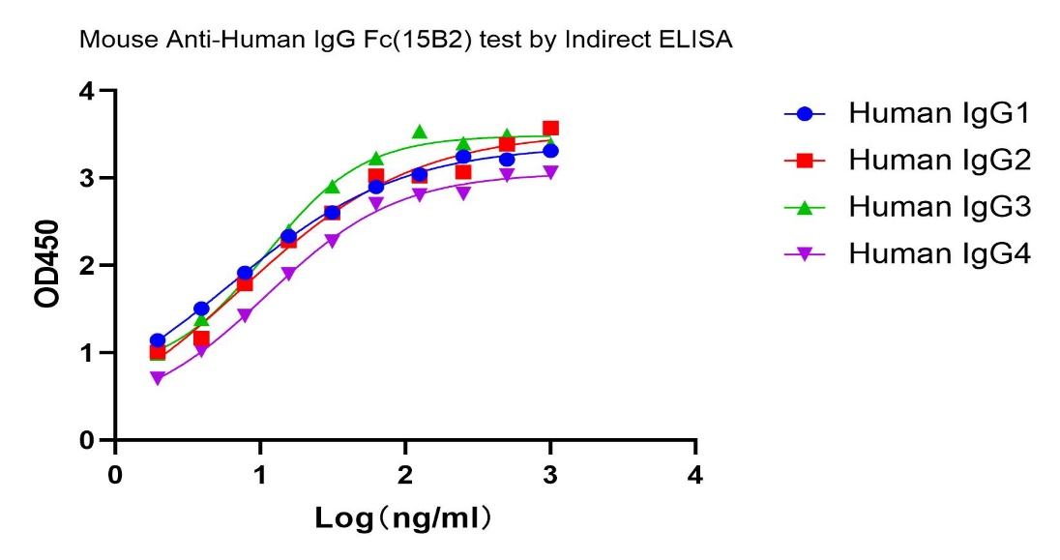

Human IgG1, IgG2, IgG3 and IgG4 were tested in Indirect ELISA with Mouse Anti-Human IgG Fc Antibody(15B2), mAb (Ningyang Biotech, Cat: NA0164). The result demonstrated that Mouse Anti-Human IgG Fc Antibody(15B2), mAb recoginzed Human IgG1, IgG2, IgG3 and IgG4.

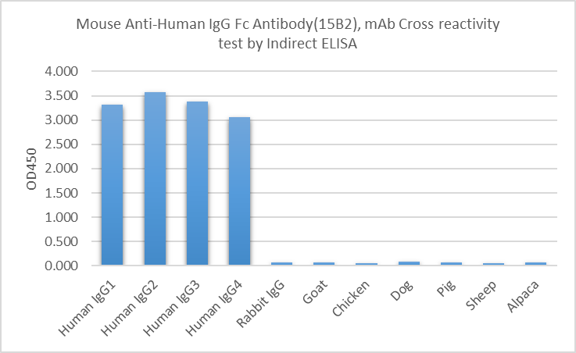

Variety of Immunoglobulin G were tested in Indirect ELISA with Mouse Anti-Human IgG Fc Antibody(15B2), mAb (Ningyang Biotech, Cat: NA0164,1μl/ml). It had no cross reactivity with rabbit, goat, chicken, dog, pig, sheep and alpaca immunoglobulins.

**For research use only.** **Not intended for human and animal therapeutic or diagnostic use.**